Online Cinema Ticket Booking System

Submitted in Fulfillment of the requirement for the award of the degree of

Bachelor of Technology
In
Computer Engineering
By
SHIVIN BAWEJA(1106733)



DEPARTMENT OF COMPUTER ENGINEERING

M.M.Engineering College, Mullana, Ambala, Haryana
Kurukshetra University, Kurukshetra, Haryana, India
December 2009

Table Of Contents

Title

- Certificate
- Preface
- Acknowledgement
- Organization Profile
- Introduction to ASP.NET using C#
- Introduction to ONLINE CINEMA TICKET BOOKING SYSTEM
- Planning Phase
- Analysis Phase
- Design & Implementation
- Screen Shots & their Description
- Testing
- Bibliography



PREFACE

Effective management of projects is vital for the development of economy because development itself is the effect of series of successful managed projects. This makes project management extremely important problem area for developing economy such as ours. Unfortunately many projects experience schedule slippage and cost overruns due to variety of reasons. To remedy the situation, a project has to be meticulously planned, effectively implemented and professionally managed to achieve the objective of the time, cost and performance. Computerization of the project management can play a major role in streamlining the management of project. Thus we see the computer becoming necessity in the day to day life. The use of computer also involves the feeling of healthy competition with the organization receiving much attention these days. Almost everyday uses of paper carry advertisements asking for project managers. The scenario was not so bright a few years back. For that matter even today though lots of seminars are held on project management, name of the universities in India offer any course to students to formally qualify as project managers. Thus, while there is very little supply. This has created all sorts of problems. Project management, unfortunately, is not but project manager practice, our attempts to demonstrate how project management, as it is concerned, can be put into practice.

ACKNOWLEDGEMENT

We would first like to thank God for showering his kind blessings on us. We owe deep gratitude to our college H.O.D Dr R.B Patel, for being helpful and encouraging all the time. We would also like to thank our Training & Placement teacher Mrs. Santosh Bhardhwaj (Programmer) for extending his kind support and guidance throughout the training period July 2009 to September 2009 and from the bottom of our heart in helping us in the learning process and being the constant source of motivation. Besides our respected teacher mentioned, we would also like to thank all the staff at DOEACC, we came in contact at DOEACC with during our training period, for their helpful and kind nature. Last but not the least, we are grateful to our parents for being so supportive and constantly inspiring us to perform better.

Organisational Profile
INTRODUCTION TO DOEACC

Constitution:
DOEACC Centre, Chandigarh is an autonomous society registered under The Societies Registration ACJXX9 of 1886. it is an autonomous body of Deptt. Of Information Technology, Ministry of Communications and Information Technology, Government of India. It was established in 29th March, 1978 (Registration No. 1003). It works on no profit no loss basis.

Objective:
- Encourage and promote the development and progress of Electronic Data Processing towards achieving self-reliance in the field of computer sciences and technology for scientific research and development, educational, governmental, commercial and industrial applications both for indigenous utilization as well as for export.

- Advance interdisciplinary co-operation amongst scientists, technologists, engineers , administrators and commercial entrepreneurs for the growth of teaching, research and practice of Electronic Data Processing System and Allied subjects in Academic Institutions, Centre and State Govts, Industrial Commercial and Research and Development Organizations.

- Disseminate knowledge on all aspects of Electronic Data Processing Systems and allied subjects and to favor the development of this specialized branch of technology.

- Simulate and offer aid for research and development for the benefit of manufacturers and users of Electronic Data Processing Systems.

- Help in the improvement of standards, terminology equipments, methods and implementation practices in the field of Electronic Data Processing System.

- Provide support for software development on consultancy basis.

- Establish, manage and operate sub Centres for all or any of the objectives of the centres, in addition to these objectives the Centre may involve in the following activities:

  - Setup advisory and consultancy services.

  - Organize study programs, symposiums, conferences, lectures.

  - Maintain contacts with other learned and professional organizations.

  - Support publication activities.

  - Make available facilities of the Centre for the users.

INTRODUCTION TO C#

Let’s look at the key building blocks of .NET and some related technologies.

- C#, a new language

C# is the first component oriented language in the C and C++ family of languages. It is a simple, modern, object oriented and type- safe programming language derived from C and C++. C# combines the high productivity of Microsoft Visual Basic and the raw power of C++.

- Common language runtime

The high performance common language runtime includes as execution engine, a garbage collector, post in time compilation, a security system, and a rich class framework (the .NET Framework). The runtime was designed from the ground up to support multiple languages.

- Common language Specification

The Common Language Specification (CLS) describes a common level of language functionality. The relatively high minimum bar of the CLS enables the creation of a club of CLS compliant languages. Each member of the club enjoys dual benefit: complete access to .NET functionality and rich interoperability with other compliant languages. For e.g. a Visual Basic class can inherit from a C# class and override its virtual methods.

- A Rich Set Of Languages That Target The Runtime

Microsoft provided languages that target the runtime include Visual Basic, Visual C++ with Managed Extensions,
Visual C# and J Script. Third parties are providing many other languages- too many to list he

LANGUAGES USED
Why .NET?

  - Interoperability between languages and execution environments
  - Uniformity in schema or formats for Data Exchange using XML, XSL
  - Extend or use existing code that is valid
  - Programming complexity of environment is reduced

The .NET Framework is…

- A component model for the internet
- The new approach to building large scale distributed systems for the Internet
- Provides the capability to integrate multiple devices
- Built around the tools and protocols (XML, WSDL, SOAP, HTTP) that are becoming standard on the Internet

The .NET in ASP.NET stands for the .NET Framework, a set of objects and blueprints from Microsoft for building applications. All applications developed under the .NET Framework; including ASP.NET applications, have certain key features that ensure compatibility, security, and stability.
Common Language Runtime (CLR) is an environment that manages the execution of code. With the .NET Framework and CLR, we write code and compile it. However, instead of compiling it into the computer understands, we compile it into a language called Microsoft Intermediate Language (MSIL). When we compile to MSIL, your application produce something called metadata. This is descriptive information about your application. It tells what the application can do, where it belongs, and so on. When you want to run your program, the CLR takes over and compile the code once more into the computer’s native language. This way MSIL can go on any type of computer. The CLR can speak many different computer languages and does all the compiling for you. Once you compile your application, you can bring it to any other computer. CLR also provides services such as error handling, security features, versioning and deployment support, as well as cross-language integration. That means we can choose any language we want to write our .NET applications, including ASP.NET applications.

The .NET Framework Design Goals
1. Component Development for the Internet
2. "Cross-Language Development”
3. Inheritance, Debugging, Exception handling
4. Reliability and Security
5. Simple Development and Deployment
6. Device-agnostic

ASP.NET:
ASP.NET is a technology that allows us to build and control dynamic Web pages easily. It also provides many enhancements to take advantage of new technology as we can interact with databases, personalize Web pages for visitors, display page on mobile devices (such as cell phones), and even build an entire e-commerce site from scratch.
Previously internet works on request/response model that is an integral part of client/server model. Although this is a marvelous way of communicate and distribute information, it's rather simple and static. When the process is over, once client receives the requesting page from the server the server has no idea what the client is doing unless it makes another request.
There is another model for communicating between server and clients, known as event-driven model.ASP.NET work on this model, it detects action and responds to them i.e. the server waits around for something to happen on the client. Once it does, the server takes action and performs some piece of functionality. Of course, a Web, server can not know what you are thinking, but it can respond to your actions. If you type some text on Web page, the server responds to it. If you click an image, the server responds.

COMPARISON OF ASP AND ASP.NET:

- Classic ASP was built on the top of the Windows operating system and IIS (Internet Information Server). It was always a separate entity, and therefore its functionality was limited. ASP.NET, on the other hand, is an integral part of the system under the .NET Framework. It shares many 9f the same objects that traditional applications would use and all .NET objects available for ASP. NET’s consumption.
- Instead of being limited to six inherent objects in ASP, ASP.NET has a plethora of useful components it can build form.
- ASP also made it abundantly clear that client and server were two separate entities, Whereas ASP. NET ties together the client and the server through clever use of server-side and client-side code, all invisible to the developer.
- ASP.NET code is compiled, whereas classic ASP used interpreted scripting languages. Using compiled code means an automatic boost in performance over ASP applications.
- In classic ASP, nearly all of the code was executed in code render blocks (that is, inside <%...%> tags). In ASP.NET, this type of code isn’t compiled and isn’t recommended for frequent use. Instead, you use the code declaration blocks, which are compiled and provide better performance.
Following are some of the significant new features of ASP.NET:
- ASP.NET uses compiled code written in Common Language Runtime languages such as Visual Basic and C#. Unlike previous versions of Active Server Pages, this version does not use interpreted scripting languages such as VBScript.
- ASP.NET pages are built out of server-side controls. Web server controls enable you to represent and program against Hypertext Markup Language (HTML) elements using an intuitive object model.
- ASP.NET includes a new technology called Web Services. You can use Web Services to access methods and properties and transfer database data across the Internet.

DBMS

SQL SERVER:
SQL Server is an SQL-compliant RDBMS. SQL-compliant means it use the ANSI (American National Standard Institute) version of Structured Query Language or ‘SQL’. Structured Query Language is a command that allow us to modify or retrieve information from the database.

Client server means that SQL Server is designed to store data in the central location (the server) and deliver it on demand to numerous other locations (the client). SQL Server is also a Relational Database Management System (RDBMS).

FEATURES OF SQL SERVER 2005:
- Information representation
- Unique definition of rows
- Systematic treatment of Null values
- Guaranteed access
- High level Update, Insert, and Delete
- Retrieving information from the database.
- Accepting query language statements.
- Enforcing security specifications.
- Enforcing data integrity specifications
- Enforcing transaction consistency
- Managing data sharing
- Optimizing queries

SOFTWARE DEVELOPMENT LIFE CYCLE

Feasibililty Analysis
Feasibility study is done so that an ill-conceived system is recognized early in definition phase. During system engineering, however, we concentrate our attention on four primary areas of interest. This phase is really important as before starting with the real work of building the system it was very important to find out whether the idea thought is possible or not.

- Economic Feasibility: An evaluation of development cost weighted against the ultimate income or benefit derived from the developed system.

- Technical Feasibility: A study of function, performance and constraints that may affect the ability to achieve an acceptable system.

- Operational Feasibility: A study about the operational aspects of the system.

Economic Analysis
Among the most important information contained in feasibility study is Cost Benefit Analysis and assessment of the economic justification for a computer based system project. Cost Benefit Analysis delineates costs for the project development and weighs them against tangible and intangible benefits of a system. Cost Benefits Analysis is complicated by the criteria that vary with the characteristics of the system to be developed, the relative size of the project and the expected return on investment desired as part of company’s strategic plan. In addition, many benefits derived from a computer-based system are intangible (e.g. better design quality through iterative optimization, increased customer satisfaction through programmable control etc.)As this is an in-house project for the company, to be used for its own convenience and also it is not that big a project. So neither it requires a huge amount of money nor any costly tools or infrastructure need to be set up for it.

Technical Analysis
During technical analysis, the technical merits of the system are studied and at the same time collecting additional information about performance, reliability, maintainability and predictability.
Technical analysis begins with an assessment of the technical viability of the proposed system.
- What technologies are required to accomplished system function and performance?
- What new materials, methods, algorithms or processes are required and what is their development risk?
- How will these obtained from technical analysis form the basis for another go/no-go decision on the test system? If the technical risk is severe, if models indicate that the desired function can not be achieved, if the pieces just won’t fit together smoothly-it’s back to the drawing board.

As the software is vary much economically feasible, then it is really important for it to be technically sound. The software will be build among:
- MS SQL SERVER as Back End
- ASP.NET as Front End

Operational Feasibility
The project is operationally feasible. This project is being made for the convenience of the patients and doctors only. This system will greatly reduce a huge burden of doctors. So because of the above stated advantages the users of the system will not be reluctant at all.

SYSTEM ANALYSIS

INTRODUCTION:
System analysis is the process of studying the business processors and procedures, generally referred to as business systems, to see how they can operate and whether improvement is needed.
This may involve examining data movement and storage, machines and technology used in the system, programs that control the machines, people providing inputs, doing the processing and receiving the outputs.

INVESTIGATION PHASE
The investigation phase is also known as the fact-finding stage or the analysis of the current system. This is a detailed study conducted with the purpose of wanting to fully understand the existing system and to identify the basic information requirements. Various techniques may be used in fact-finding and all fact obtained must be recorded.
A thorough investigation was done in every effected aspect when determining whether the purposed system is feasible enough to be implemented.

INVESTIGATION
As it was essential for us to find out more about the present system, we used the following methods to gather the information: -

1. Observation: - Necessary to see the way the system works first hand.

2 Document sampling: - These are all the documents that are used in the system. They are necessary to check all the data that enters and leaves the system.

3 Questionnaires: - These were conducted to get views of the other employees who are currently employed in the system.
ANALYSIS OF THE INVESTIGATION

Strengths of the System

1. No complex equipment: - The equipment that is used is very simple and no special skills have to be mastered to be able to operate the system. Therefore no training is required for the employees.

2. Low cost: - There is little money spent in maintaining the present system other than buying the necessary office equipment and the ledgers.

CONSTRAINTS AND LIMITATIONS
The constraints and limitation within a system are the drawbacks that occur during the implementation of the system. These limitations and constraints can crop up in almost every system; the most important fact is to find a way to overcome these problems.
Software design is the first of three technical activities – design, code generation, and test that are required to build and verify the software. Each activity transforms information in manner that ultimately results in validated computer software.
The design task produces a data design, an architectural design, an interface design and component design.
The design of an information system produces the details that clearly describe how a system will meet the requirements identified during system analysis. The system design process is not a step by step adherence of clear procedures and guidelines. When I started working on system design, I face different types of problems; many of these are due to constraints imposed by the user or limitations of hardware and software available. Some times it was quite difficult to enumerate that complexity of the problems and solutions thereof since the variety of likely problems is so great and no solutions are exactly similar however the following consideration I kept in mind during design phased.

Design objectives:-
The primary objective of the design is to deliver the requirements as specified in the feasibility report. These are the some of the objectives, which I kept in mind.

- Practicality: The system is quite stable and can be operated by the people with average intelligence.
- Efficiency: I tried to involve accuracy, timeliness and comprehensiveness of the system output.
- Cost: It is desirable to aim for the system with a minimum cost subject to the condition that it must satisfy the entire requirement.
- Flexibility: I have tried that the system should be modifiable depending on the changing needs of the user. Such modifications should entail extensive reconstructing or recreation of software. It should also be portable to different computer systems.
- Security: This is very important aspect which I followed in this designing phase and tried to covers the areas of hardware reliability, fallback procedures, and physical security of data.
INITIAL STUDY

INTRODUCTION:
The first step in the Software Development Life Cycle (SDLC) is the preliminary investigation to determine the feasibility of the system. The purpose of the preliminary investigation is to evaluate project requests. It is not a design study nor does it include the collection of details to describe the business system in all aspect. Rather it is the collection of the information that helps committee members to evaluate the merits of the project request and make an informed judgment about the feasibility of the proposed project.

The preliminary investigation should accomplish the following objectives.

- Clarify and understand the project request.
- Determine the size of the project.
- Assess costs and benefits of alternative approaches.
- Determine the technical and operational feasibility of alternative approaches.
- Report the findings to management; with recommendations outlining the acceptance or rejection of the proposal.

Requirement And Feasibility Analysis

INTRODUCTION:

What Is A Feasibility Study?
Prior to stating whether the system we have to develop is feasible or not we believe that we should emphasize on what is implied by the word “Feasibility”. Feasibility is the measure of how beneficial or practical the development of the system will be to the organization. It is a preliminary survey for the systems investigation. It aims to provide information to facilitate a later in-depth investigation.
The report produced at the end of the feasibility study contains suggestions and reasoned arguments to help management decide whether to commit further resources to the proposed project.
Within the scheduled duration we were assigned to study both the positive and negative aspects of the current manual system, in which we have come up with a number of drawbacks that prevent the progress of the clinic if it is continued to function manually.
Having gone through all measures of feasibility we report to the management to figure out if the objectives of the new system are met.
For e.g. - Is the system within the budget allowed for it?
Will the organizations needs, be met by the new proposed system as
Originally envisaged?
If and when the objectives of the system are met and the new system is approved, then the more specific details in the proposal should be considered and approved.

Types Of Feasibility
There are various measures of feasibility that helps to decide whether a particular project is feasible or not. These measures include-
- Operational Feasibility
- Technical Feasibility
- Economical and Financial Feasibility
Each of these types will be explained in detail throughout the project report.

Operational Feasibility
A proposed system is beneficial only if it can be turned into an information system that will meet the operational requirements of an organization. A system often fails if it does not fit within existing operations and if users resist the change.

Important issues a systems developer must look into are:
- Will the new system be used if implemented in an organization?
- Are there major barriers to implementation or is proposed system accepted without destructive resistance?

The whole purpose of computerizing the Placement System is to handle the work much more accurately and efficiently with less time consumption. There will be additional work to be completed, because now the students and the companies can update their resumes and profiles online. Their database is maintained separately.

Compared to the semi-computerized system the chances of avoiding errors in a computerized system is much higher because the user need not stress himself unnecessarily resulting in recklessness. Unlike the semi-computerized system there would be backup data for all the information concerning the daily transactions occurred within the organization.
If we are considering the performance and response time for each task, it is very much faster since there is less paper work to be completed. When entering data into the system to relieve the user from additional work and typing incorrect data, the system provides options such as combo boxes, check boxes, option buttons and etc. if the users type in incorrect data they would be informed immediately about the error by the error detection control.

Another important fact to be regarded is the security control, which is handled by the system. Since data regarding each student and the company is confidential, security is a key issue. Information falling into the wrong hands could jeopardize the entire organization. Unlike in semi-computerized systems the proposed system offers adequate control to protect the organization against fraud and embezzlement and guarantees the accuracy and security of data and information. This is handled by the system providing each department and individuals with separate login names and passwords.

The new system is more user-friendly, which enables the end-user to complete his/her work efficiently and accurately with interest. After taking the above fact into consideration we can state the operating of the proposed system within the organization is feasible.

In this phase of the feasibility study the following two main topics
- Technical Performance Aspect
- Acceptance within the organization

Technical performance aspect is explained in the technical feasibility report and there is no new information is needed in this to explain it again, but as for the acceptance within the organization the following points are important and those are explained according to the topics

- Whether the system provides right information to the right place.

In the current system which is the semi computerized system the information may be lost in the process of sending from one place to another. This is mainly due to human interaction in the process of the transferring information from one place to another.

- Whether the new system affect the current users in the system

The new proposed system will affect the users in the following areas
  - Accuracy
  - Efficiency
  - Productivity
  - Robustness
  - Lesser time consuming

.

System Security
System security is a vital aspect when it comes to developing a system. The system should ensure the facility of preventing unauthorized personnel from accessing the information and the data within the system. The system should provide total protection for each user’s information so that the integrity of data is sustained and also prevent hackers from hacking the system.

The proposed system ensures the security and the integrity of data. This is done by providing a password login system for each authorized users. And for example the System Administrator has access to all kinds of information.

By providing this facility information is properly managed and information is protected. For example the system administrator’s day to day tasks are lessened and easier because he doesn’t have to have a constant eye on the system and worry about hackers hacking the system.

Economical And Financial Feasibility
In making recommendations a study of the economics of the proposed system should be made. The proposed system must be justifiable in terms of cost and benefit, to ensure that the investment in a new/changed system provide a reasonable return.

Cost-benefit analysis of information is complicated by the fact that many of the systems cost elements are poorly defined and that benefit can often be highly qualitative and subjective in nature.

In our proposed system various costs are evaluated. Even though finding out the costs of the proposed project is difficult we and assume and estimate the costs and benefits as follows.

According to the computerized system we propose, the costs can be broken down to two categories.
- Costs associated with the development of the system.
- Costs associated with operating the system.

Software Requirement Specification

The software requirement specification is produced at the culmination of the analysis task. The function and performance allocated to software as part of system engineering are refined by establishing a complete information description, a detailed functional description, a representation of system behavior, an indication of performance requirement and design constraints appropriate validation criteria, and other information pertinent to requirement.
The introduction to software requirements specification states the goals and objectives of the software, describing it in the context of the computer based system.
The Information Description provides a detailed description of the problem that the software must solve. Information content, flow and structure are documented.
A description of each function required to solve the problem is presented in the Functional Description.
Validation Criteria is probably the most important and ironically the most often neglected section of the software requirement specification.
Software requirement specification can be used for different purpose. Here are the major uses.

not clearly understood by the developer. If this is the case, a careful analysis – involving much interaction with the user should be devoted to reaching a clear statement of requirements, in order to avoid possible misunderstandings.
Sometimes, at the beginning of a project, even the user has no clear idea of what exactly the desired product is. Think for instance of user interface , a user with no previous experience with computer products may not appreciate the difference between , say menu driven interaction and a command line interface. Even an exact formation of system functions and performance may be missing an initial description produced by an inexperienced user.

A statement of the requirements for the implementation:
Specifications are also used as a reference point during product implementation. In fact, the ultimate goal of the implementation is to build a product that needs specification. Thus the implementers use specifications during design to make design decisions and during the verification activity to check that the implementation compiles with specifications.

DATABASE DESIGN:
The overall objective in the development of the database technology has been to treat data as an organizational resource and as an integrated whole. Database management system allows data to be protected and organize separately from other resources. Database is an integrated collection of data. The most significant of data as seen by the programs and data as stored on the direct storage access storage devices. This is the difference between logical and physical data. The organization of data in the database aims to achieve free major objectives:

Data Integration

Data Integrity

Data Independence

The databases are implemented using a DBMS package. Each particular DBMS has unique characteristics and general techniques for Database Design.
The proposed Management Information System stores the information relevant for processing in the Microsoft SQL Server Database. This MS SQL Server contains tables, where each table is called a field or column. A table also contains records which is a set of fields. All records, in a table the same set of fields with different information. Each table contains key fields that establish relationships in a MS SQL server database and how the records are stored. There are primary key fields that uniquely identify a record in a table. There are also fields that contain the primary key from another table called foreign keys.
It is a known fact that the program cannot be written until the data are defined, so the database must be defined. The starting point for this process is data dictionary. The records data structures and elements to be stored in each database are identified and extracted.
SYSTEM REQUIREMENTS

The basic system requirements for running this project are listed below:

- Microsoft Windows 2000 professional, Microsoft Windows XP Home editions, Microsoft Windows XP Professional edition

- Sql Server 2005

- Microsoft .net Framework 2.0

- Pentium or equivalent microprocessor(400 MHz or faster)

- At least 256 MB of RAM

- At least 10MB of free hard disk space

- CDROM

- Video graphics and monitor with at least 800 X 600 resolution

SCHEMA DESIGN:

INTRODUCTION:

In database design, several views of data must be considered along with the persons who use them. In addition to data structuring, where relationships are reflected between and within entities, we need to identify the application program’s logical views of data within an overall logical data structure. The logical view is what the data look like, regardless of how they are stored. The physical view is the way data exist in physical storage. It deals with hoe data are stored, accessed, or related to other data in storage.

The schema is the view that helps the DBMS decide in storage act upon as requested by the application program.

RELATIONAL MODEL:
Certain rules followed in creating and relating databases in the relational databases. This governs how to relate data and prevent redundancy of the data in the databases. The first set of rules called relational rules ensures that the database is a relational database. The second set called the normalization rules simplifies the database and reduce the redundancy of the data.

CODE DESIGN
When large volumes of data are being handled, it is important that the item be identified, stored or selected easily and quickly. To accomplish this, each data item must have unique identification and must be related to other items of the same type. Codes can provide brief identification of each item, which replace longer description that would be more awkward to store and manipulate.

The ability to interrupt codes, evaluate coding schemes and devices new or improved codes are important skills for a system analyst. Common types of codes are:

SEQUENCE CODES:

A sequence code has no relation to the characteristics of an item. Here a dictionary is required. The data is arranged alphabetically and numbered sequentially. When a new data item is added it is given the next sequence number. The advantage of this code is that it has the ability touched with an unlimited number of digits.

SIGNIFICANT DIGIT CODE:
It is a code in which the number describes measurable physical characteristics of the item.
ALPHABETIC CODE:

Here, the item are specified by the user of letter and number combinations,

SELF CHECKING CODE:
It uses a check digit to check the validity of codes. These types of codes are an important means of controlling the validity of data that are being processed.

VALIDATION CHECKS:
A common problem with computer system is that it is very easy to put incorrect data into them. So the input data is validated to minimize errors and data entry. For certain data specific code has been given and validations are done which enable the user to enter the required data and correct them if they have entered wrong codes, e.g. you could mistype a link name or a URL in a database resulting in reports being occurred in the wrong link name. if you put incorrect data into the computer system then you will get incorrect results out of it. Processing incorrect inputs will produce incorrect outputs. This lead to the acronym: GIGO (Garbage In Garbage Out).

Sometimes incorrect data can actually cause a computer system to stop work temporarily. This is a particular problem in batch processing systems when data may be processed overnights. If incorrect data stops a batch processing systems for working then a whole night processing time may be lost.

People who develop computer systems go to a lot of trouble to make it difficult for incorrect data to be entered. The two main techniques used for this purpose are:

- VERIFICATION
- VALIDATION

Verification:
A verification check ensures that data i9s correctly transferred into a computer from the medium that it was originally stored on. Verification checks are usually used to check that a data entry worker has correctly typed information written on a data collection form into a computer.

Methods of Verification:
The two most common methods of verification are:

On-Screen prompts: After a user has entered some data it is redisplayed on the screen. The user is prompted to read the data and confirm that it has been entered correctly. If the user has entered any data incorrectly he should response that the data is inaccurate and retypes the incorrect parts.

- Dual Inputs: This method is used when data is entered through the keyboard. The data to be entered is typed in twice by two different operations. The two copies of data are been compared, any difference are detected, the operators will be prompted to retype the sections that differ until both copies agree.

- VALIDATION:

A validation check is an automatic check made by computer to ensure that any data entered into the computer is sensible. A validation check does not make sure that data has been entered correctly. It only ensures that data is sensible. For this reason validation checks are not usually as effective as verification checks. They can however be carried out automatically by the computer and therefore require less work by the computer operators making them cheaper to use.

Methods of validation:
There are many different methods of validations. The most appropriate method to use will depend upon what data is being entered. The most common methods are listed here.

Presence Checks: checks that data has been entered into the field and that it has not been left blank, e.g. checks that Project ID is always entered into each record in a database of project details.
- Type Checks: checks that an entered value is of particular type. E.g. checks that a field is varchar, a number, etc.

Length Checks: checks that an entered value, e.g. Project ID is no longer than a particular number of characters.
- Format Checks: Checks that an entered value has a particular format. E.g. a date must be consist of “mm-dd-yy” format.
Validation checks can be performed by any piece of software. If the user tries to do unauthorized operations the appropriate error messages are produced by the systems.

DATA DICTIONARY:

In our DFD, we give names to data flows, processes, and data stores. Although the names are descriptive of the data, they do not give details. So the following the DFD, our interest is to build some structured place to keep details of the contents of data flow, processes, and data store. A data dictionary is a structured repository of data about data. It is a set of rigorous definition of all DFD data element and data structure.

A data dictionary has many advantages. The most obvious is documentation; it is valuable reference in any organization. Another advantage is improving analyst/user communication by establishing consistent definition of various elements, terms and procedures. During implementation, it serves as a common base against which programmers who are working on the system compare data description. Also control information maintained for each data element is cross referenced in the data dictionary. E.g. program that use a given data element are cross referenced in a data dictionary, which makes it easy to identify them and make any necessary changes. Finally, a data dictionary is an important step in building a database. Most database management system has a data dictionary as a standard feature.

INPUT DESIGN:

The input design is the link between the information system and the user. It comprises developing specification and procedure for data preparation and those steps that are necessary to put transaction data into a usable form for processing data entry. The activity of putting data into the computer for processing can be achieved by instructing the computer to read data from a written or printed document or it can occur by having people key data directly into the system. The design of inputs focuses on controlling the amount of inputs required, controlling errors, avoiding delay, avoiding extra steps and keeping the process simple.

SYSTEM TESTING

INTRODUCTION:
The purpose of system testing is to identify and correct errors in the candidate system. Testing is and important element of software quality assurance ad represents the ultimate review of specification, design and coding. The increasing visibility of the software as a system element and the cost associated with a software failure are motivated forces for well planned, through testing.

System testing was conducted in order to detect errors and for comparing then the final system with the requirement specification reports, i.e. whether the system meets requirements. During testing the software was executed with the set of test cases and the output of programs for the test cases was evaluated to determine if the program is performing as it was expected to.

Testing presents an interesting challenge for the software engineers attempt to build software from an abstract concept to an acceptable implementation. In testing engineer create a series of test cases that occurs when errors are uncovered. Testing is the process of executing a program for finding errors. A good test is one that has the high probability of finding an uncovered error. A successful error is one that uncovers undiscovered errors.

The term error is used to refer the difference between actual output of the software and the current output. Fault is a condition that causes the software to fail to perform its required function. Software reliability is defined as a required function. Software reliability is defined as the probability that the software will not undergoes failures for a specified times under specified condition. Failure is the inability of a system or a component to perform a required function according to its specification. Different levels of testing were employed for software to make it error free, fault free and reliable.

Unit Testing:

Unit testing was conducted first. Different modules of the software were tested against the specifications produced during design of the modules. Verification of the code produced during the coding phase was done. Each module was tested separately.

Unit testing focuses verification effort on the smallest unit of software design module. This uncovers errors within the boundary of a module. Unit testing is actually White box testing both the external things as well as the internal codes are tested. In testing, the interfaces are tested in order to ensure the proper flow of data in and out of the module. The boundary testing is done to ensure that the module keeps the limit of it. All independent paths are tested to ensure that all statements are tested at least once. At last the error path is also tested.

Unit testing comprises the set of tests performed by an individual programmer prior to integration of the unit into a larger system. There are four categories of test that can be performed on a program unit

Functional Unit
- Performance Unit

Stress Unit
- Structure Unit

System Testing:

Then system testing was conducted. Here the entire software system was tested.
The reference document used for this process was requirement document and the goal was to see if the software meets its requirements.

System testing includes the thorough testing of the product. System testing is actually a series of different tests whose primary purpose is to fully exercise the computer based system. The tests are recovery testing: this checks the recovery of the system when failure occurs. This is to ensure that there are recovery procedures for error occurrences.
System testing involves unit testing, integration testing, acceptance testing. Careful planning and scheduling are required to ensure that modules will be available for integration into the evolving software product when needed. A test plan has the following steps:

Prepare test plan
- Specify conditions for user acceptance testing

Prepare test data for program testing
- Prepare test data for transaction path testing

Plan user testing
- Compile/Assemble program

Prepare job performance aids

Prepare operational documents

Objectives of testing.
First of all objectives should be clear.
- Testing as a process of executing a program with the intent of finding errors.
- To perform testing, test cases are designed. A test case is a particular made up of artificial situation upon which a program is exposed so as to find errors. So a good test case is one that finds undiscovered errors.
- If testing is done properly, it uncovers errors and after fixing those errors we have software that is being developed according to specifications.

Online Cinema Ticket Booking Description

Welcome to newly designed website cinema ticket booking is a faster, cleaner and a tad more personal website, specially designed to make your booking experience better. Log on, navigate and find out for yourselves and if time permits leave your valuable feedback.
Customers may view the contents of any movie show at any time and may book any movie ticket as needed. The program automatically calculates the subtotal and grand total. When a visitor decides to finally book the ticket, the order information including the buyer's name, address and billing instruction is stored in the database securely and payment has been made.

The combo booking is also provided at the time of booking the ticket and there’s a wonderful facility of delivering the combos at your seat when you are watching the movie.

You need to register a new user whenever you have first visited or site then for future it will be stored in our database permanently and you can book you movie ticket at any time you want with this username and password.

Online Cinema Ticket Booking Features

- Database Search Feature
- Supports credit card transactions
- Supports SQL database for movie database for speedy movie info lookups.
- Can save customer contact information for their next visit, so they do not have to re-type it.
- Using the SQL module the cart can handle very large product databases.
- Ability to store order information in a secure file
- Ability to order more than one ticket and combo at a time
- Ability to assign the different seat numbers to different users.

Online Cinema Ticket Booking Working

The booking information is kept in a text database, which consists of: combo cost, username, seat type, no of seats booked, ticket cost and net payable amount to be paid by the customer. This database is modified when the user books the ticket.
The customer can be presented with a booking page, which allows them to add more of the same items or remove items from the combo items. The booking page also shows the seat type to be booked, no of seats to be booked, service charges to be applied, ticketing cost and net payable amount to the customer.
When the customers have done their booking they will checkout using the payment information page. This page collects data about the customer, his bank name, his credit card number, credit card type, address, telephone number, mobile number, and CVV information.

DATA
FLOW
DIAGRAM

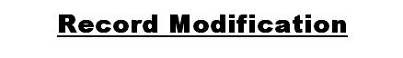

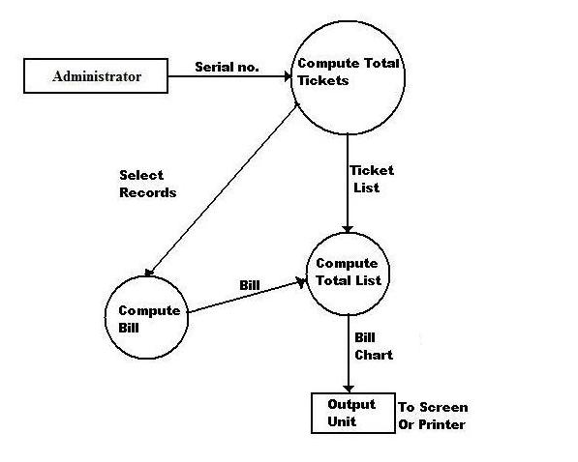



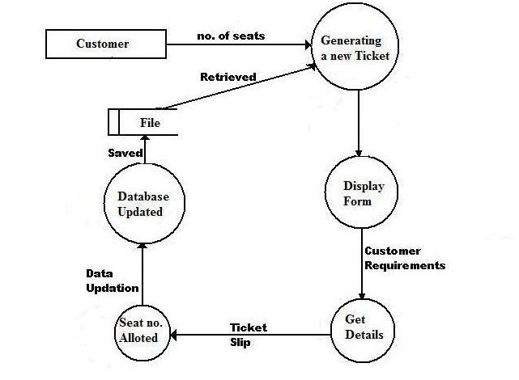



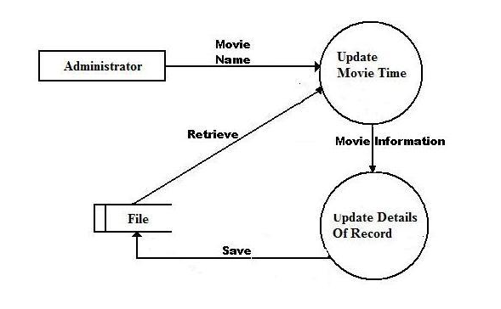



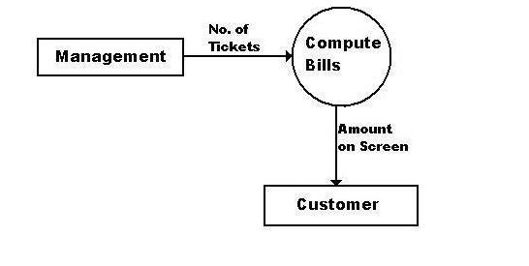



Home Page

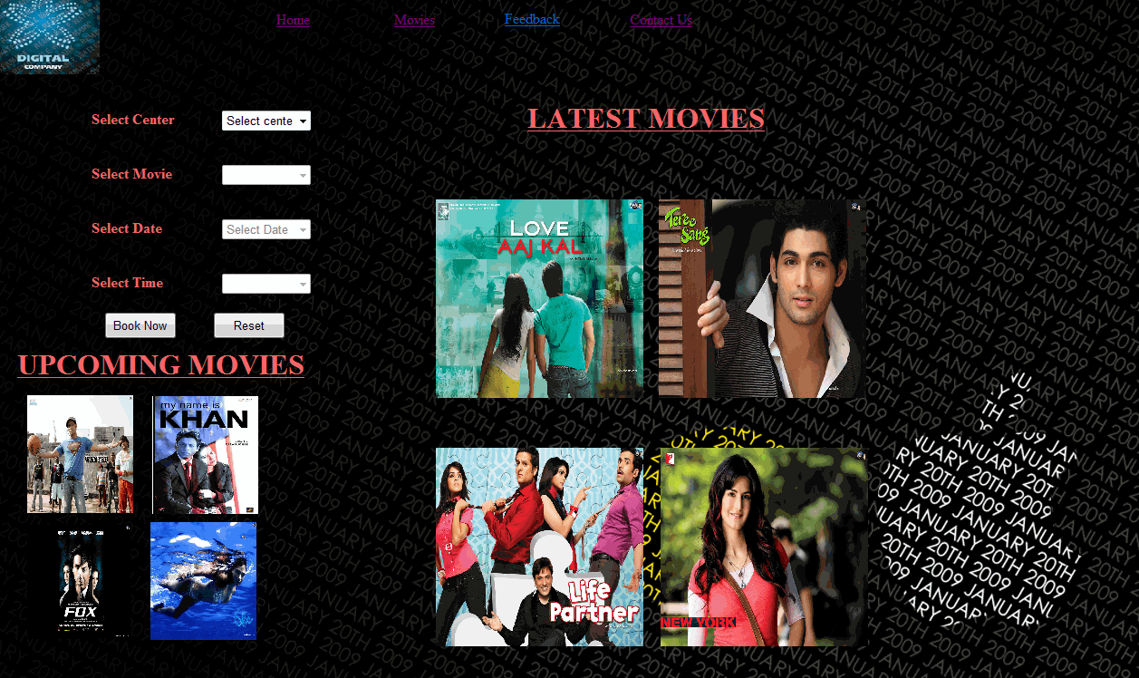

New User’s Registration Page

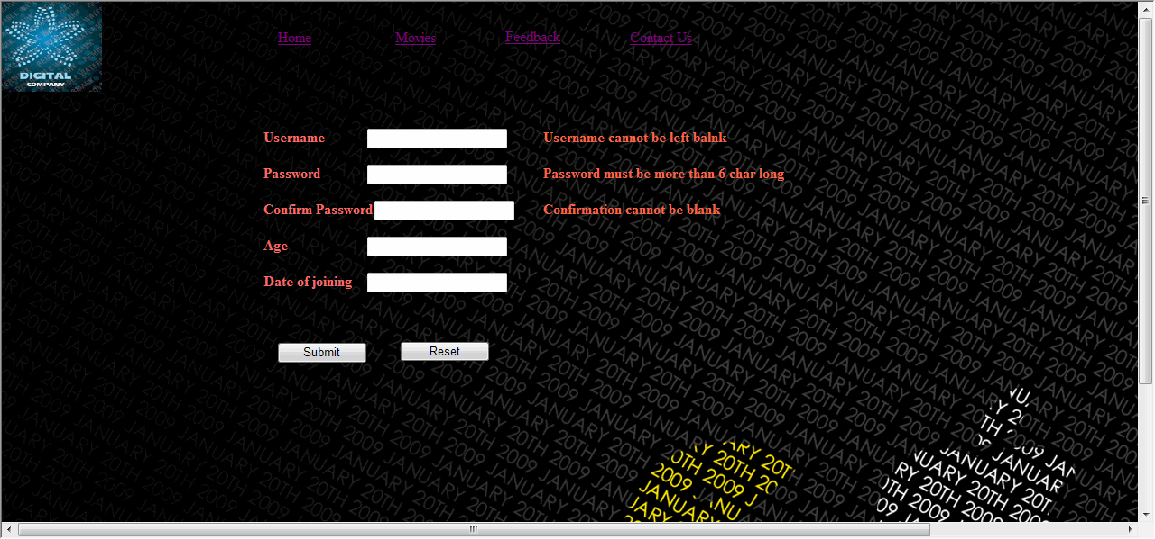

This page will allow new users to register themselves with the website.

User’s Login Page

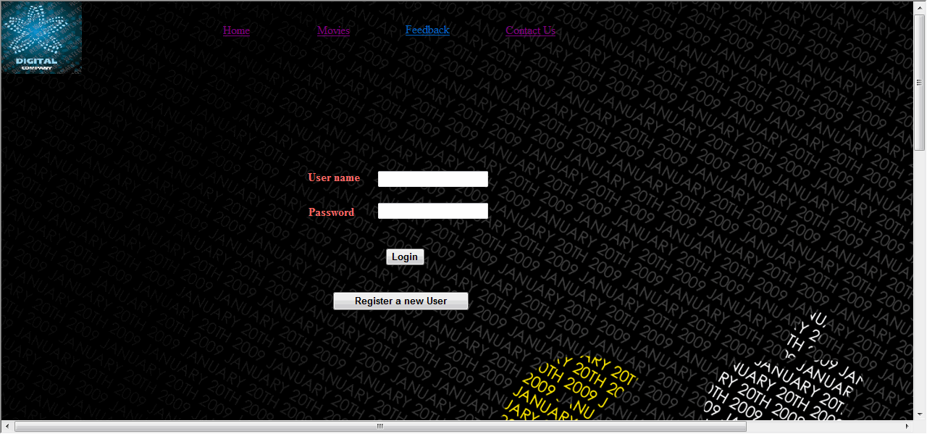

This webpage allow users to login in their account. The customer can also navigate back to home page.

Ticket Booking Page

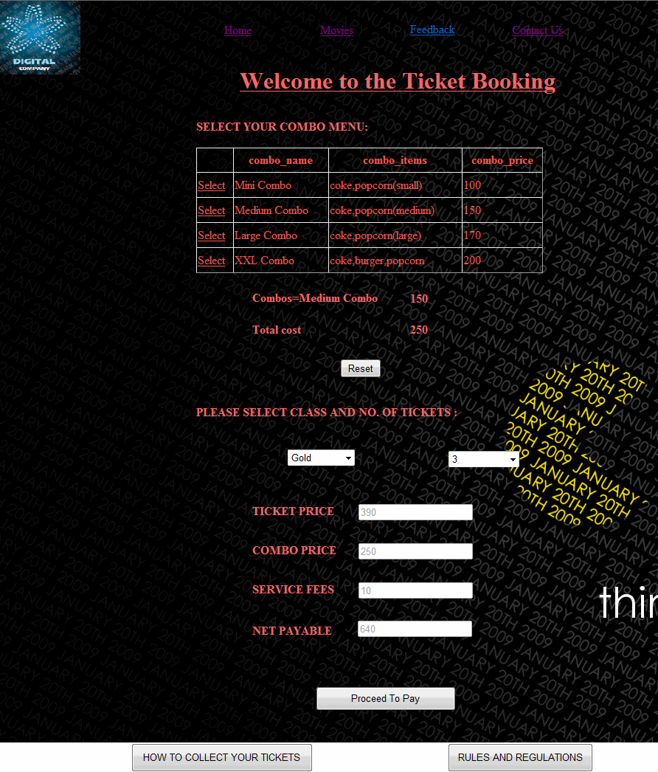
Payment Information Page
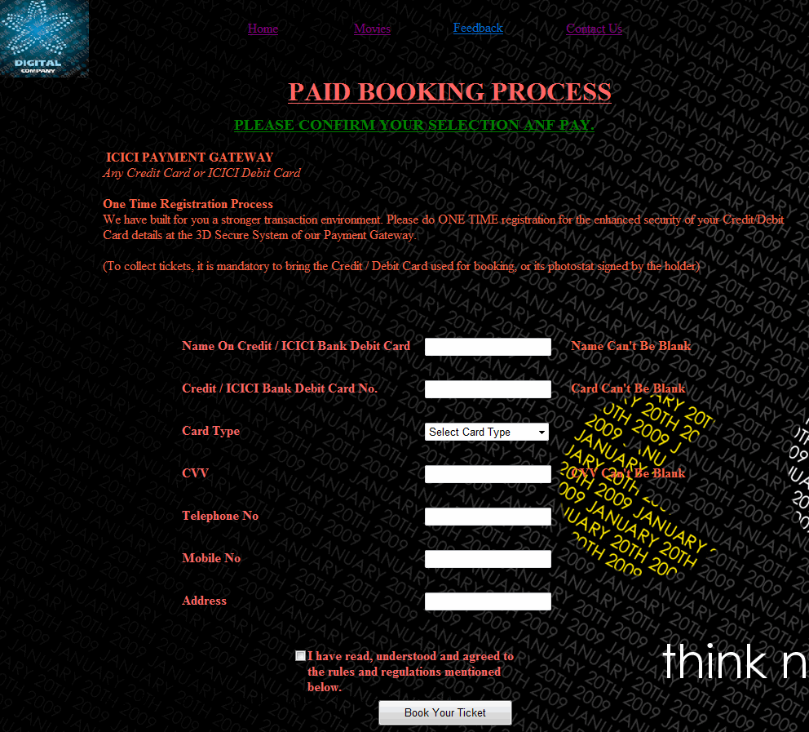

This page demands the user about what payment method he want to use.
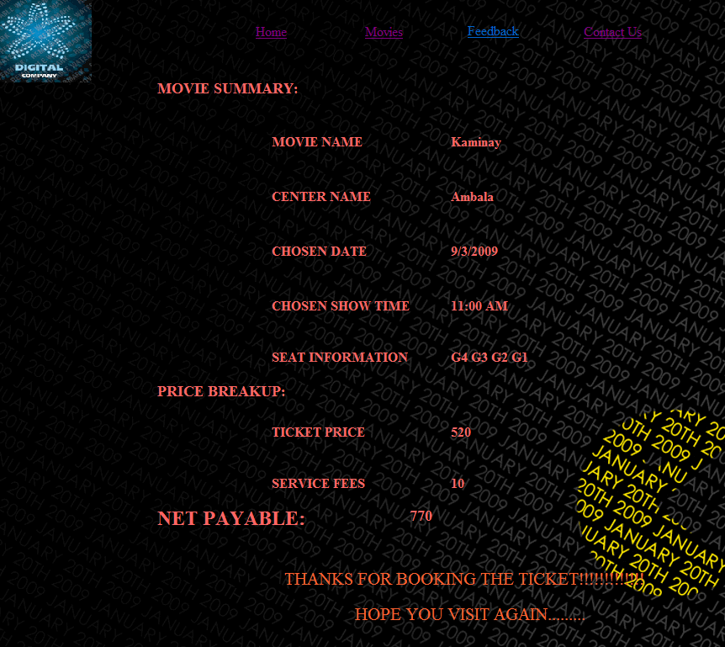
Page when Ticket is booked

This page displays the ticket information when the ticket is booked.
Rules And Regulations Page
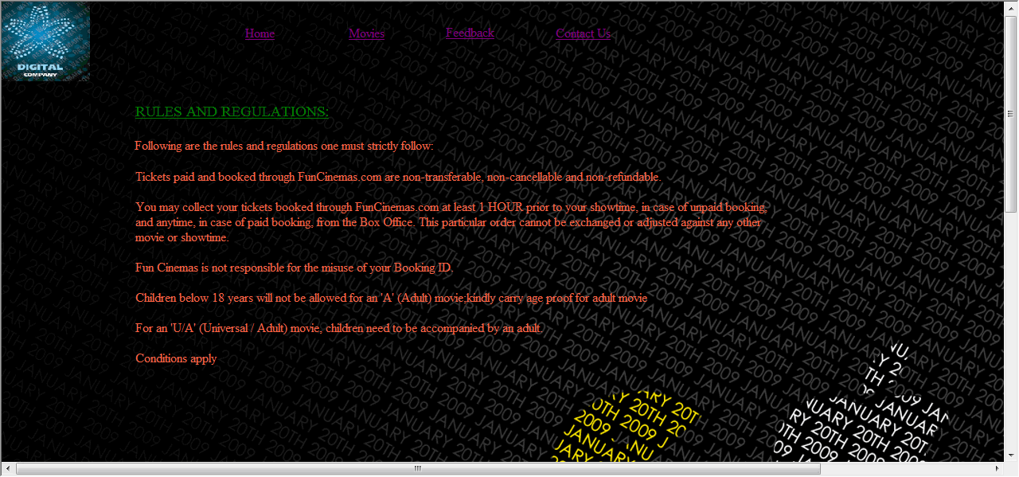

It displays the rules and regulations which the customer has to follow.
Movies Page
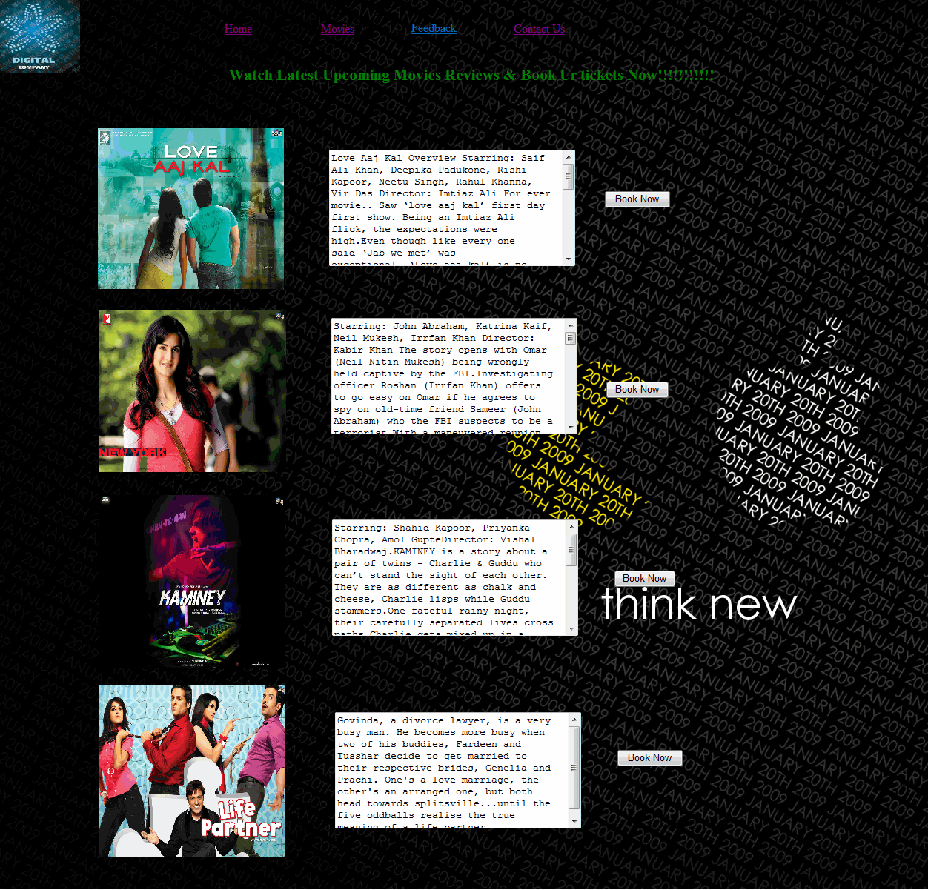
Feedback Page
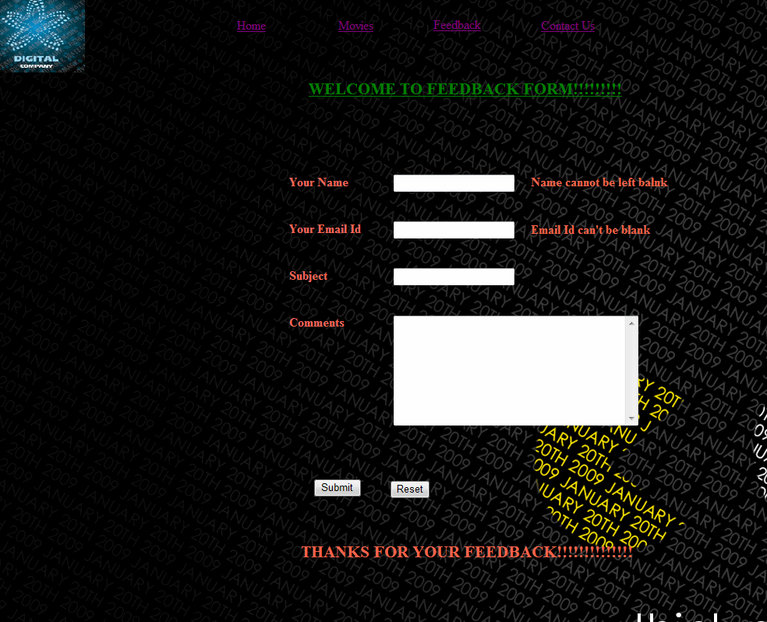
This page receives the valuable feedback of the customer.
Tables Used in Database

Centers and movies names information

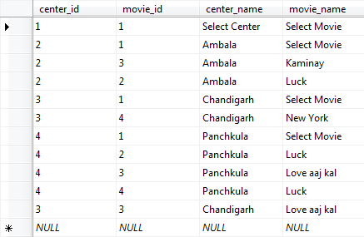

This page stores the movie information i.e. which movie is running at which center.

Movie Information

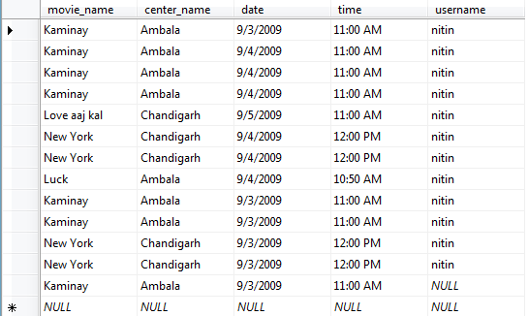

This page stores the information about the movie schedule

Booking Page

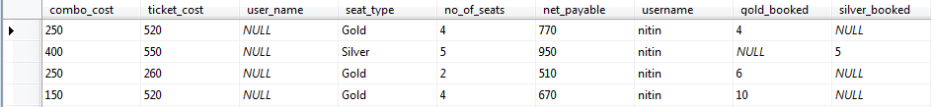

This page keeps the information of combo cost, ticket cost, username, type of seat booked by the customer and so on…

Booking Data

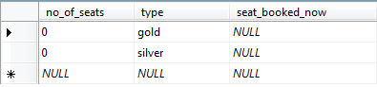

This page stores the information about how many gold and silver tickets are currently booked.



Coding of home.aspx.cs

using System;
using System.Data;
using System.Configuration;
using System.Collections;
using System.Web;
using System.Web.Security;
using System.Web.UI;
using System.Web.UI.WebControls;
using System.Web.UI.WebControls.WebParts;
using System.Web.UI.HtmlControls;
using System.Data.SqlClient;

public partial class home : System.Web.UI.Page
{
public static DateTime tm;

protected void Page_Load(object sender, EventArgs e)
{

tm = DateTime.Today;
//drp_select_movie.Items.Add("Select Center");

}

protected void drp_select_movie_SelectedIndexChanged(object sender, EventArgs e)
{
drp_select_date.Items.Clear();
drp_select_date.Items.Add("Select Date");
drp_select_date.Items.Add(Convert.ToString(tm.ToShortDateString()));
tm = tm.AddDays(1);
drp_select_date.Items.Add(Convert.ToString(tm.ToShortDateString()));
tm = tm.AddDays(1);
drp_select_date.Items.Add(Convert.ToString(tm.ToShortDateString()));
drp_select_date.Enabled = true;
drp_select_date.Visible = true;
drp_select_movie.Enabled = false;

}

protected void drp_select_date_SelectedIndexChanged(object sender, EventArgs e)
{
drp_select_time.Enabled = true;
drp_select_time.Visible = true;
//drp_select_time.Items.Add("Select Time");
drp_select_date.Enabled = false;
}
protected void drp_select_center_SelectedIndexChanged(object sender, EventArgs e)
{
drp_select_movie.Enabled = true;
drp_select_movie.Visible = true;
//drp_select_movie.Items.Add("Select Movie");
drp_select_center.Enabled = false;
}
protected void drp_select_time_SelectedIndexChanged(object sender, EventArgs e)
{

}
protected void btn_reset_Click(object sender, EventArgs e)
{
Response.Redirect("home.aspx");
}
protected void btn_book_now_Click1(object sender, EventArgs e)
{
SqlConnection conn = new SqlConnection();
conn.ConnectionString = ConfigurationManager.ConnectionStrings["cinema_tckt_bookingConnectionString"].ConnectionString;
conn.Open();
string center =Convert.ToString( drp_select_center.SelectedItem);
string movie = Convert.ToString( drp_select_movie.SelectedItem);
string date = drp_select_date.SelectedValue;
string time = Convert.ToString( drp_select_time.SelectedItem);
string sql = "insert into movie_info (center_name,movie_name,date,time) values('" + center + "','" + movie + "','" + date + "','" + time + "')";
SqlCommand cmd = new SqlCommand(sql, conn);
cmd.ExecuteNonQuery();
string del="delete from booking_info";
string del1 = "delete from booking";
string insert = "insert into booking (no_of_seats,type) values('0','gold')";
string insert1 = "insert into booking (no_of_seats,type) values('0','silver')";
SqlCommand delete = new SqlCommand(del, conn);
SqlCommand delete1 = new SqlCommand(del1, conn);
SqlCommand inser = new SqlCommand(insert, conn);
SqlCommand inser1 = new SqlCommand(insert1, conn);
delete.ExecuteNonQuery();
delete1.ExecuteNonQuery();
inser.ExecuteNonQuery();
inser1.ExecuteNonQuery();
Response.Redirect("login.aspx?m="+movie);
}
}

Coding of login.aspx.cs

using System.Configuration;
using System.Data;
//using System.Linq;
using System.Web;
using System.Web.Security;
using System.Web.UI;
using System.Web.UI.HtmlControls;
using System.Web.UI.WebControls;
using System.Web.UI.WebControls.WebParts;
//using System.Xml.Linq;
using System.Data.SqlClient;
public partial class login : System.Web.UI.Page
{

protected void Page_Load(object sender, EventArgs e)
{

}
protected void btn_login_Click(object sender, EventArgs e)
{
string u = Request.QueryString["m"];
SqlConnection conn = new SqlConnection();
conn.ConnectionString = ConfigurationManager.ConnectionStrings["cinema_tckt_bookingConnectionString"].ConnectionString;
conn.Open();
string sql = "select * from login where username='" + txt_uname.Text + "' and password='" + txt_password.Text + "'";
SqlCommand cmd = new SqlCommand(sql, conn);
SqlDataReader dr;
dr = cmd.ExecuteReader();
if (dr.Read())
{
conn.Close();
conn.Open();
string sql1 = "update movie_info set username='"+txt_uname.Text+"' where movie_name=('"+ u +"')";
SqlCommand cmd1 = new SqlCommand(sql1, conn);
cmd1.ExecuteNonQuery( );
lbl_message.Text = "login sucessfull";
Response.Redirect("booking.aspx?q="+txt_uname.Text);
}
else
lbl_message.Text = "login failed";
}
protected void btn_register_Click(object sender, EventArgs e)
{
Response.Redirect("register.aspx");
}
}

Coding of booking.aspx.cs

using System;
using System.Collections;
using System.Configuration;
using System.Data;
//using System.Linq;
using System.Web;
using System.Web.Security;
using System.Web.UI;
using System.Web.UI.HtmlControls;
using System.Web.UI.WebControls;
using System.Web.UI.WebControls.WebParts;
using System.Data.SqlClient;

public partial class Booking : System.Web.UI.Page
{
int ticket_price=0;
int total_cost;

protected void Page_Load(object sender, EventArgs e)
{
GridView1.SelectedIndex = -1;
}
protected void GridView1_SelectedIndexChanged(object sender, EventArgs e)
{
string display="Combos=";
int s;
total_cost = 0;
s = GridView1.SelectedIndex;
switch (s)
{
case 0:
total_cost +=Convert.ToInt16(lbl_total_price.Text);
display += Convert.ToString(GridView1.SelectedValue);
lbl_combo_cost.Text = "100";
total_cost += 100;
break;
case 1:
total_cost += Convert.ToInt16(lbl_total_price.Text);
display += Convert.ToString(GridView1.SelectedValue);
lbl_combo_cost.Text="150";
total_cost += 150;
break;
case 2:
total_cost +=Convert.ToInt16( lbl_total_price.Text);
display += Convert.ToString(GridView1.SelectedValue);
lbl_combo_cost.Text = "170";
total_cost += 170;
break;
case 3:
total_cost +=Convert.ToInt16( lbl_total_price.Text);
total_cost += 200;
lbl_combo_cost.Text = "200";
display += Convert.ToString(GridView1.SelectedValue);
break;
}
lbl_combo_display.Text = display.ToString();
lbl_total_price.Text=total_cost.ToString();

}

protected void btn_reset_Click(object sender, EventArgs e)
{
total_cost = 0;
lbl_total_price.Text = "0";
}
protected void btn_seat_select_Click(object sender, EventArgs e)
{
if (DropDownList2.SelectedIndex == 0)
lbl_error1.Text = "please select the ticket type and quantity";
else
{
string w = Request.QueryString["q"];
Response.Redirect("Payment.aspx?e=" + w);
}
}
protected void btn_how_to_collect_tckt_Click(object sender, EventArgs e)
{
Response.Redirect("how to collect your ticket.aspx");
}
protected void btn_rules_regulations_Click(object sender, EventArgs e)
{
Response.Redirect("rule and regulations.aspx");
}
protected void DropDownList2_SelectedIndexChanged(object sender, EventArgs e)
{
string w = Request.QueryString["q"];
total_cost =Convert.ToInt16(lbl_total_price.Text);
if (DropDownList1.SelectedValue == "1")
ticket_price = 130;
if (DropDownList1.SelectedValue == "2")
ticket_price = 110;
int s =Convert.ToInt16(DropDownList2.SelectedValue);
ticket_price = ticket_price * s;
txt_ticket_price.Text = ticket_price.ToString(); ;
txt_ticket_price.Enabled = false;
txt_combo_price.Text = total_cost.ToString();
txt_combo_price.Enabled = false;
txt_service_fees.Text = "10";
txt_service_fees.Enabled = false;
int net_payable;
net_payable = total_cost + ticket_price;
txt_net_payable.Text = net_payable.ToString();
txt_net_payable.Enabled = false;

SqlConnection conn = new SqlConnection();
conn.ConnectionString = ConfigurationManager.ConnectionStrings["cinema_tckt_bookingConnectionString"].ConnectionString;
conn.Open();
int a = Convert.ToInt16(txt_combo_price.Text);
int b = Convert.ToInt16(txt_ticket_price.Text);
string c = Convert.ToString(DropDownList1.SelectedItem);
int d = Convert.ToInt16(DropDownList2.SelectedValue);
int f = Convert.ToInt16(txt_net_payable.Text);
string seat_typ="1",total_seat="1";
if (DropDownList1.SelectedValue == "1")
{
seat_typ = "select no_of_seats from booking where type='gold'";
total_seat = "select gold from seats";
}
if (DropDownList1.SelectedValue == "2")
{
seat_typ = "select no_of_seats from booking where type='silver'";
total_seat = "select silver from seats";
}
SqlCommand seat = new SqlCommand(seat_typ, conn);
SqlCommand tot_seat = new SqlCommand(total_seat, conn);
total_seat = tot_seat.ExecuteScalar().ToString();

int t_seat= Convert.ToInt16(total_seat);
string seat_info = seat.ExecuteScalar().ToString() ;
int drp=DropDownList2.SelectedIndex;
int s_info= Convert.ToInt16(seat_info);
s_info = s_info + drp;
string sql,no_of_seats,type;
if(s_info<t_seat)
{
if (DropDownList1.SelectedValue == "1")
{
type = "update booking set no_of_seats='" + s_info + "',seat_booked_now='gold' where type='gold'";
sql = "insert into booking_info (username,gold_booked,combo_cost,ticket_cost,seat_type,no_of_seats,net_payable) values('" + w + "','" + s_info + "','" + a + "','" + b + "','" + c + "','" + d + "','" + f + "')";
}
else
{
type = "update booking set no_of_seats='" + s_info + "',seat_booked_now='silver' where type='silver'";
sql = "insert into booking_info (username,silver_booked,combo_cost,ticket_cost,seat_type,no_of_seats,net_payable) values('" + w + "','" + s_info + "','" + a + "','" + b + "','" + c + "','" + d + "','" + f + "')";
}
SqlCommand typ = new SqlCommand(type, conn);
SqlCommand cmd = new SqlCommand(sql, conn);
typ.ExecuteNonQuery();
cmd.ExecuteNonQuery();
}
else
Response.Write("not enough seats available");

}
}

CONCLUSION OF THE PROJECT

The project has been developed successfully and the performance of the system has been found satisfactory. The security has been incorporated as required by any placement firm. Use of computer helps the user in reducing the time wasted in non-productive work. It further helps the user in having immediate access to the information as well as to share the limited resources effectively.

User friendly menu driven interface has been provided to the user to interact with the system. Users can traverse through the website provided the users have the access right set. The users can register themselves through a registration form and then can use the services of the website.

The system provides an integrated environment for the customers who are willing to watch movies currently running in the audi and can also enjoy combo packs while watching movie.

LIMITATIONS OF THE PROJECT

The following are the limitations of the project:

- No Multi-User Support Is Provided

At a time only one user can use the software. In same companies, the computers are interconnected to form a network. But this software will work on only one computer at a time.

- Login Password Is Not Encrypted

The username and password provided to us is not encrypted properly. Any person that gets to know the username and password of a user can access his account. So keep your password safe.

- No Backup And Restore Utilities Are Incorporated

In these times of uncertainties, incorporation of the facilities of backup and restoration of last details is necessary. Any computer can crash or become affected by a virus at any time. So it is imperative to take the backup of the data, but this software does not provide this utility.

REFERENCES
- www.google.com
- www.howstuffworks.com
- www.bing.com
- www.wikiepedia.org
- www.microsoft.com
- ASP.NET by Wrox Publications
- ASP.NET 2.0 Unleashed
- Comdex ASP.NET

